LAB - 6

|  |  |
| --- | --- |
| Name | Keval D Gandevia |
| Roll Number | CE046 |
| ID | 19CEUEG017 |
| Subject | Big Data Analytics |

**Aim:** Connecting to NoSQL database and querying to provide analysis using api like aggregation, etc. To be able to successfully import/export from/to csv.

* **Verifying mongod service:**

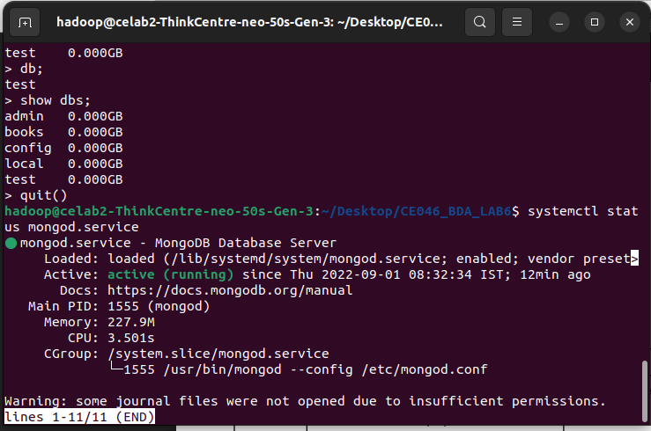

* **Creating a collection:**

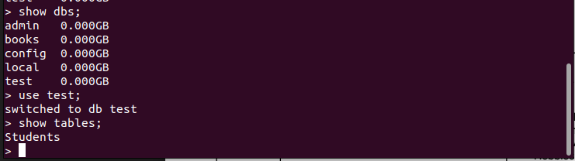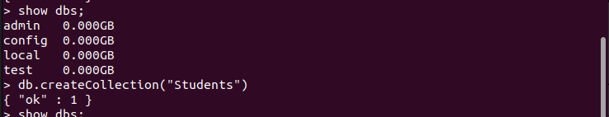

* 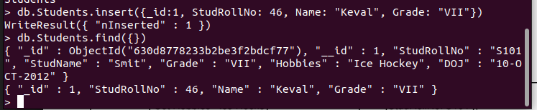**Inserting data into the table:**
* **Updating the documents of the collection:**

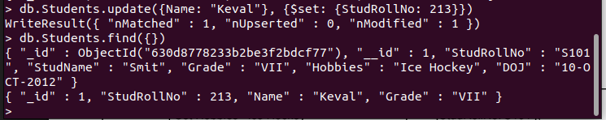

* **Updating multiple rows simultaneously:**

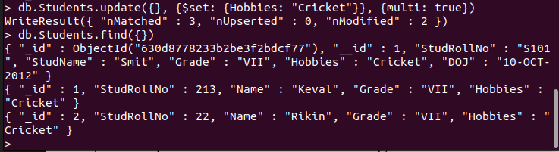

* 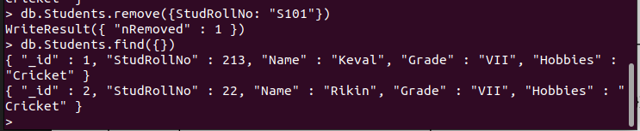**Removing the documents from the collection:**
* 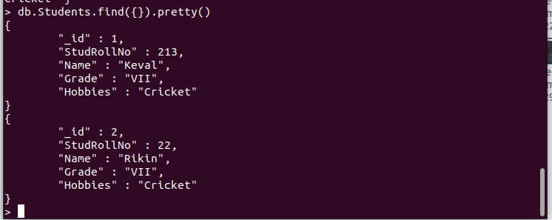**Getting the documents from the collection:**

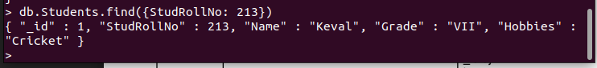

**Exercises:**

**Q. 2: Write the insert method to store the following document in MongoDB.**

* 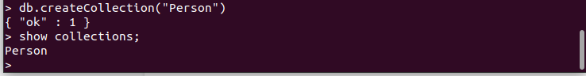**Creating a collection named ‘person’:**
* **Inserting a data as given in the question into the collection:**



* 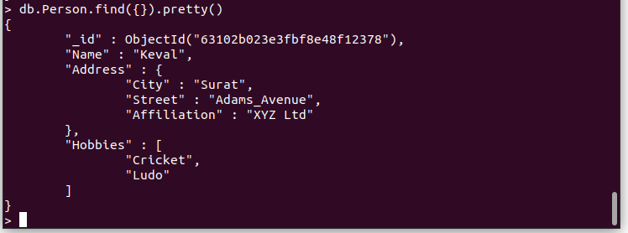**Output using find () method:**

**Q. 3: Practice MapReduce programming in MongoDB.**

* **Creating a collection named ‘Books’:**

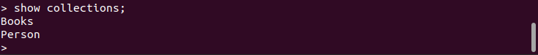



* **Inserting demo data into the collection ‘Books’:**







* **Data is added successfully.**

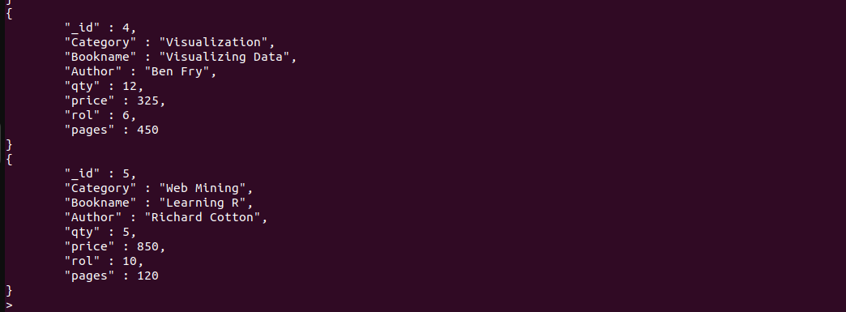

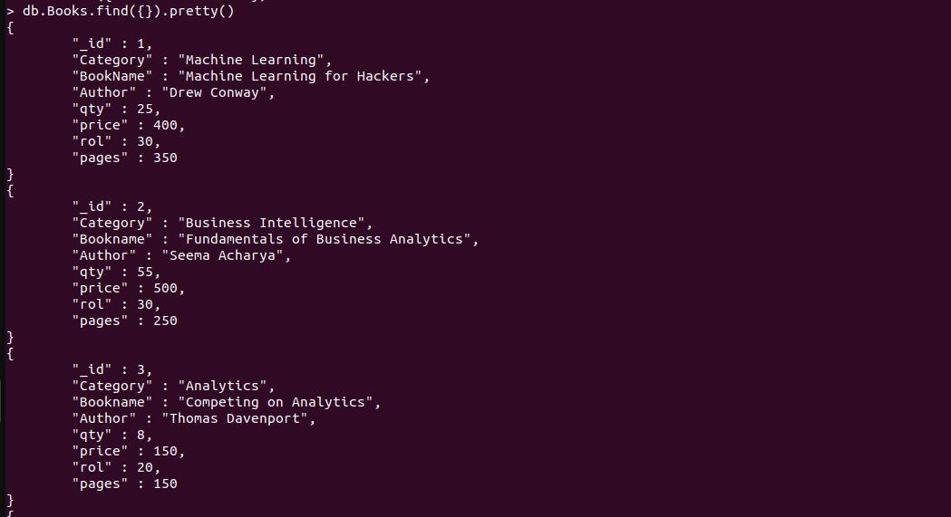

* **Creating functions for map and reduce and using mapReduce method of the mongoDB and storing the result into the collection ‘Book_Result’.**

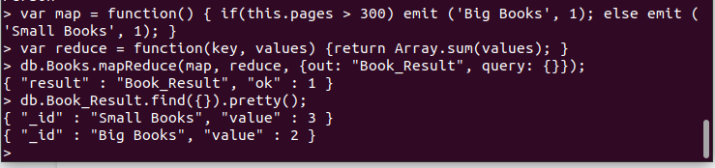

**Q. 4: Practice import and export and aggregation in MongoDB.**

* **Importing a csv file into collection using a command mongoimport.**

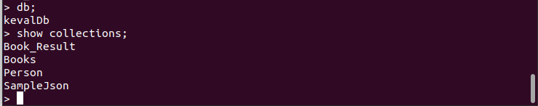

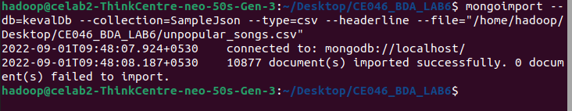

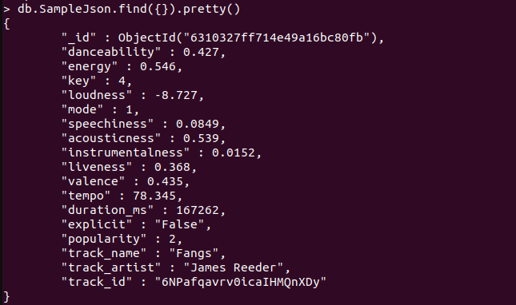

* **Compute the sum of the values in the first numeric column.**



* **Compute the average of the values in the second numeric column.**

